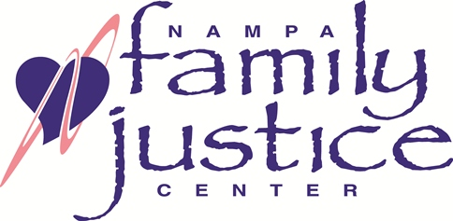

ELDER JUSTICE

Creating Community Awareness

Training Registration

When: Friday, June 15, 2018

8:00 a.m. to 12:00 p.m.

Where: Nampa Police Department
(Baker room, left off the entrance lobby)
820 2nd St. S. Nampa, 83651
Cost: None
Please submit registration to Lana McCullough at
mcculloughl@cityofnampa.us
or
Fax: 208 475-5710

Name:________________________________________________________________________________________________

Agency:______________________________________________________________________________________________

Position/Title:______________________________________________________________________________________

Phone: _______________________________________________________________________________________________

Email: ________________________________________________________________________________________________

